Job Description

JOB TITLE: Family Care Nurse Speciliast - Palliative
DIVISION: Family Health
GRADE: Band 7
REPORTS TO: Lead Nurse for Neonatal Home Care and Family Care
ACCOUNTABLE TO: Lead Nurse for Neonatal Home Care and Family Care

VALUES AND BEHAVIOURS

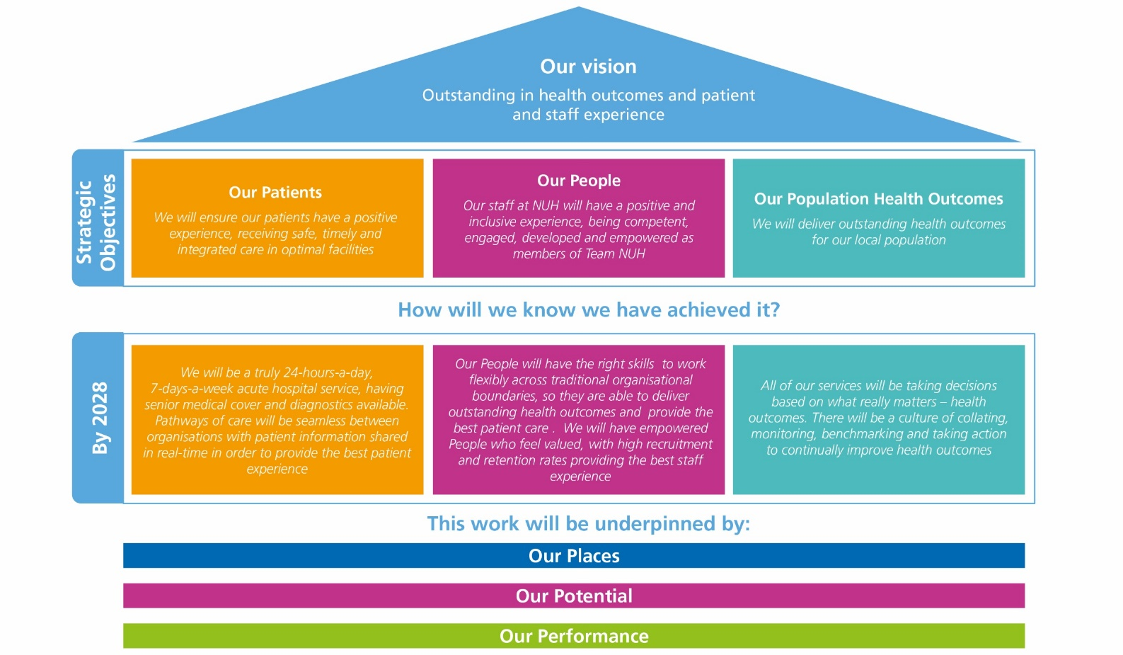

ABOUT NUH

Every day, our teams at Nottingham University Hospitals NHS Trust (NUH) make a difference. We save lives, we improve lives and we usher in new life. We are proud to play a central role in supporting the health and wellbeing of people in Nottingham, Nottinghamshire and our surrounding communities.

With more than 18,000 colleagues, we are the largest employer in Nottinghamshire and one of the biggest and busiest NHS Trusts in the country, serving more than 2.5m residents of Nottingham and Nottinghamshire and a further four million people across the East Midlands and beyond.

We provide a range of national and internationally renowned specialist services and we are at the forefront of new surgical procedures and research programmes.

We are home to the East Midlands Major Trauma Centre, the Nottingham Children's Hospital and in partnership with the University of Nottingham we host a Biomedical Research Centre carrying out vital research into hearing, digestive diseases, respiratory, musculoskeletal disease, mental health and imaging.

As a teaching hospital, we are instrumental in the education and training of doctors, nurses and other healthcare professionals. We are proud of our strong relationships with universities across the East Midlands, including the University of Nottingham, Nottingham Trent University and Loughborough University.

The last year has been challenging for our teams. Alongside our continued recovery from Covid, our maternity services are subject to an independent review and we must do more to improve our culture. We are more focused than ever on making sustained improvements across our services.

As one of the NHS Trusts identified in the New Hospital Programme, a programme of investment in NHS hospitals, we have extensive plans to improve our hospitals and the services we deliver for patients. As well as the redevelopment of the Queen’s Medical Centre and City Hospital, plans for a new 70 bed NHS rehabilitation facility set to be built on the Stanford Hall Rehabilitation Estate near Loughborough, are currently going through the approvals process.

We have recently become home to the latest series of Channel 4’s award-winning series 24 Hours in A&E, which takes a look inside one of the country’s busiest emergency department at QMC and showcases the dedication, passion and skill of our teams.

This is an exciting time to join NUH and help support our future ambitions.

JOB SUMMARY

The Family Care Nurse Specialist - Palliative will provide support to families who are expecting a baby or have had a baby who is in the neonatal unit and may have limited life expectancy. The post holder will provide a confidential palliative care support for families, including the emotional support of siblings, grandparents and other people important to the baby.

The role incorporates antenatal support of women and their families, support on the neonatal unit and continuing to support the family after discharge. The post holder will also be visiting families in their own home or chosen place of care. The neonatal palliative care nurse specialist will work within the broader family care team and will be expected to provide holistic family care support to the patients and families of NUH. Travel around the region will be required.

The Family Care Nurse Specialist - Palliative will provide guidance and support to multi-disciplinary staff on the unit to care for babies at their families. The post holder will be an expert clinical practitioner in the care of babies with life limiting illness and will act as a resource and role model both face to face and during telephone consultations. The palliative care nurse specialist will be an advocate for parallel planning and building relationships with parents of seriously unwell babies.

The post holder will act as an educational resource for staff on physiological, psychology and administrative aspects of palliative care The nurse specialist will also provide ongoing supervision and support, participating in the induction and training of the multi-disciplinary team in both formal and informal settings. The post holder will be responsible for organising and facilitating debriefs following clinical events on the unit.

The Family Care Nurse Specialist - Palliative will be responsible for managing other members of the bereavement team to ensure consistency of care leading to a high quality seamless service. The post holder will be expected to develop a palliative care pathway providing support for personalised care planning, anticipatory care planning, symptom management and ensuring appropriate services around the child are in place.

The Family Care Nurse Specialist - Palliative is expected to work on both acute campuses and also within community settings such as patient homes, hospice or alternative environments in order to meet the families’ needs. The neonatal palliative care nurse specialist is expected to act as a liaison between the family and other professionals.

The Family Care Nurse Specialist- Palliative will have protected time to maintain and further develop their professional competence. As a senior member of the team, the nurse specialist will also play a pivotal role in the operational development of their specialty. They will initiate, manage and drive change within the department, innovating changes in practice for the benefit of patient care in line with current trust and local programmes.

KEY JOB RESPONSIBILITIES

1.0 Clinical
1.1 Utilising a highly developed specific body of knowledge, work within the neonatal team to deliver a service based on principles that are research based and which enhance the quality of patient and family based care.
1.2 Undertakes high-level complex decision-making, managing risk but may defer to others for overall plan. 1.3 Be a visible point of contact for patients, visitors, relatives, and staff, acting as the patients advocate 1.4 Ensure that the rights, dignity and confidentiality of the child and family is protected at all times in line with safeguarding policies and within the philosophy of family centred care.
1.5 Ensure that patient’ records and documentation are maintained and current, with changes implemented, in accordance with NUH ‘Clinical record keeping policy.
1.6 Organise meetings to discuss patient management as required.
1.7 Provide highly specialist support to clinical teams in dealing with the complex needs of dying patients and bereaved families.
1.8 Undertake personalised care planning, parallel planning and high quality end of life are planning for babies and their families.
1.9 To ensure families and multidisciplinary staff are able to access further support where requested such as SANDS, Petals and Bliss.
1.10 Liaise closely with other health and social care professionals to ensure a coordinated approach and high quality care is provided for patients.
1.11 To refer families for formal bereavement counselling, at the request of the parents, or where identified by healthcare professionals.
1.12 Discuss alternative treatment options and facilitate clinical management decisions. To promote parallel planning during antenatal care planning and inpatient phases of care.
1.13 Obtain informed consent for procedures as required, in accordance with the Trust consent policy. 1.14 Participate in research studies in conjunction with the specialty team and lead studies as appropriate. 1.15 Promote and support personalised care in line with the NHS long-term plan including the components of the comprehensive model for personalised care.
1.16 Provide clinical support to wards/departments in times of increased clinical pressure or staffing shortages as requested, ensuring that patient safety is the priority at all times. Be a clinical expert.
1.17 Working with services e.g. police and child death team after unexpected deaths. Reporting and documenting concerns.

2.0 Education, Learning & Development
2.1 Provide a credible source of highly specialist clinical knowledge and advice, taking an active role in the development of self and others. Review the performance of self and others, identifying development needs and taking active measures to meet those needs.
2.2 Carry out formal and informal teaching to a range of health care professionals and in a range of subjects. Develop and deliver educational and training programmes as requested and as appropriate
2.3 Create a positive learning environment within clinical settings, to encourage and facilitate individual and shared learning and professional development.
2.4 Participate in the education of patients and the general public, developing resources as necessary.
2.5 Maintain an awareness and understanding of relevant, up to date research studies within neonatal services and bereavement care.

3.0 Leadership and Management
3.1 Support the senior team as appropriate.
3.2 Deputise and represent other sisters/charge nurses within the neonatal unit during absence.
3.3 Develop pathways and guidelines related to palliative care in neonatal services
3.4 Respond to and lead as necessary on clinical governance initiatives eg complaints, datix
3.5 Initiate and implement change effectively in response to clinical or organisational demands. React positively to, lead and facilitate the process of effective change through a culture of Shared Governance and frontline leadership.
3.6 Be a representative at a local level and participate as a member of the senior neonatal nursing team, making positive contributions to the strategic planning of the service.
3.7 Ensure clinical supervision within the clinical area or department is actively supported and staff encouraged to avail themselves of it.
3.8 Lead on the development of team objectives.
3.9 Participate in interviewing and selection of new staff.
3.10 Be aware of the impact of service changes across the organisation.
3.11 Participate in the managerial duties at Specialty level as required in the absence of the Matron.
3.12 Audit the service to aid in the improvement of continuous patient care.
3.13 Work closely with the appropriate teams and individuals eg case manager/PALS to ensure any concerns raised by families are dealt with quickly and effectively and through the processes.

4.0 Service Development and Use of Resources
4.1 Identify and implement innovative ways of working within the family care team.
4.2 Share and promote good practice through involvement with local groups, including presentations, publication and dissemination of role evaluation.
4.3 In collaboration with the lead nurse and other members of the MDT, take a leading role in ensuring that the family has a satisfactory experience by assessing and evaluating family care processes and redesigning the pathway of care when appropriate.
4.4 Contribute to the monitoring and control of expenditure and the use of resources.
4.5 Participate in objective setting and business planning for the family care team.
4.6 Implement change in response to clinical, organisational and national demands; in agreement with appropriate others in the neonatal unit. Support others to lead or participate in the management of change.
4.7 Respond to change initiatives in a positive manner
4.8 Lead and participate in audits, research and the development of evidence – based patient care guidelines, protocols, policies and procedures where appropriate and ensure they are implemented.
4.9 Ensure that the neonatal unit and wider team is kept informed of the policies, direction and strategy of the family care team.
4.10 Critically appraise and evaluate research findings and lead on the application of these to clinical practice.
4.11 Lead practice developments, through specific research and audit projects.
4.12 Provide statistics, service reviews and evaluations of care to the matrons for performance reports. 4.13 Collect and analyse information related to patient and carer satisfaction and evaluation of the service initiating service development strategies as indicated.
4.14 Develop mechanisms to measure outcomes and evaluate the service to assist with service development
4.15 To represent NUH at a regional and national level relating to neonatal bereavement care.

5.0 Communication and Professional Behaviour
5.1 Be a role model to ensure that the dignity, rights and confidentiality of the patient and individual team members are protected and maintained in accordance with Trust and national policy on Information Governance.
5.2 Convey and present complex and sensitive information, written or verbal, formally or informally, as appropriate. Report appropriate clinical information to senior staff. Ensure that written documentation is kept in respect of all investigations and incidents.
5.3 Establish professional relationships and maintain effective communication
5.4 Link with, and where required lead, professional networks across the Trust and wider health community, in order to develop and exchange ideas for improving clinical care
5.5 Provide ongoing liaison and support for patients and families within care pathways.
5.6 To establish and maintain an effective working relationship with the neonatal team, spiritual care team, mortuary staff, pathologist, wider bereavement team and other healthcare professionals and outside agencies where appropriate.

Working Conditions
Mental Effort - Concentrate for frequent periods with a predictable work pattern i.e. clinics, patient homes, on the neonatal unit - Be able to support bereavement families and cope with the death/dying of patients.

Physical Effort - Lift and manoeuver patients as required - Handle equipment as required

Emotional Effort - Handle challenging behaviour from families – this may be frequent - Share and impart unwelcome news

GENERAL DUTIES
In addition to the key job responsibilities detailed in this job description all employees at Nottingham University Hospitals NHS Trust are expected to comply with the general duties detailed below:
Infection Control
To maintain a clean, safe environment, ensuring adherence to the Trust’s standards of cleanliness, hygiene and infection control.

For senior/clinical managers the following statement must also be included
The post holder is accountable for minimising the risks of infections and for the implementation of the Code of Practice for the Prevention and Control of Healthcare Associated Infections as outlined in the Health Act 2006. This includes receiving assurance of risk and embedding evidence based practice into daily routines of all staff.

Safeguarding children, young people and vulnerable adults
Nottingham University Hospitals is committed to safeguarding and promoting the welfare of children, young people and vulnerable adults. All staff and volunteers are therefore expected to behave in such a way that supports this commitment.

Information Governance
All staff have an individual responsibility for creating accurate records of their work and for making entries into and managing all NHS records effectively in line with the Health Record Keeping Policy and other Health Records and Corporate Records Management policies and procedures in order to meet the Trust’s legal, regulatory and accountability requirements.

Health and Safety
To take reasonable care to prevent injury to themselves or others who may be affected by their acts or omissions.

To co-operate fully in discharging the Trust policies and procedures with regard to health and safety matters.

To immediately report to their manager any shortcomings in health and safety procedures and practice.

To report any accidents or dangerous incidents to their immediate manager and safety representative as early as possible and submit a completed accident/incident form.

To use protective clothing and equipment where provided.

Whilst the aim of the Trust is to promote a co-operative and constructive view of health and safety concerns in the organisation, all staff must be aware that a wilful or irresponsible disregard for safety matters may give rise to disciplinary proceedings.

Governance
To actively participate in governance activities to ensure that the highest standards of care and business conduct are achieved.

Health and Wellbeing
Employees are expected to take all reasonable steps to look after both their physical health and mental health. To support employees to achieve this NUH offers a wide range of health and wellbeing activities and interventions. The full programme can be viewed at on the staff intranet.

Line managers are expected to encourage and support staff to look after their health and wellbeing, including the release of staff to attend health and wellbeing activities and interventions.

General Policies Procedures and Practices
To comply with all Trust policies, procedures and practices and to be responsible for keeping up to date with any changes to these.

WORKING CONDITIONS
Describe the post holder’s normal working conditions (such as exposures to hazards, requirement for physical effort etc).

JOB REVISION
This job description should be regarded as a guide to the duties required and is not definitive or restrictive in any way. The duties of the post may be varied from time to time in response to changing circumstances. This job description does not form part of the contract of employment.

Service Review
A strategic review of all Trust services is taking place, as a result of which some services, or parts of some services, may transfer from one campus to the other. This will be decided in accordance with the most appropriate way to provide the best healthcare for patients in the future and all staff will be fully consulted on about the impact of any such decisions.

Job description reviewed by:
Date:

