Contents

Welcome 3

About West London NHS Trust 4

How we are organised 6

Our Trust Values 7

Job Description 8

Person Specification 11

How to Apply 12

Main terms and conditions 13

Welcome

Dear Candidate,

Thank you for your interest in the Trainee Psychological Wellbeing Practitioner (PWP) - position. This pack provides you with all the information you may need to apply for this vacancy.
- Please note all applications should be submitted on this link directly to the university.
- Please do not apply directly to the advert.
Why choose us? West London NHS Trust has grown significantly in the last two years with investment in mental health services and this growth is set to continue over the next five years. In 2019, the Trust expanded its portfolio to include community services in Ealing and beyond, through our Integrated Care Services. We are incredibly proud that more staff than ever would recommend us a place to work and we have seen a 28% increase in staff engagement in the national staff survey over the last 5 years.
We are on a significant journey of transformation in the quality of services provided, through greater co-production with service users and carers, and addressing long-standing inequalities. Increasingly, we are leading and collaborating closely with Integrated Care Partnerships and at the wider system level, as a strong voice for integrated services and the most vulnerable in society.
Thank you for your interest in this trainee role and I wish you every success with your application with the university.
Yours sincerely

Ruth Dennis
Head of Psychology for the Psychological Medicine Service Line

About West London NHS Trust
West London NHS Trust is one of the most diverse healthcare providers in the UK, delivering a range of mental health, physical healthcare and community services commissioned locally and nationally. The Trust runs Broadmoor Hospital, one of only three high secure hospitals in the country with an international reputation.

Our high secure services care for patients from across the South of England and we provide low and medium secure services covering eight London boroughs. The Trust also provides mental and physical healthcare in three London boroughs – Ealing, Hammersmith & Fulham and Hounslow. The Trust employs over 3800 staff, of which 51% are from a Black and Asian Minority Ethnic (BAME) background. Our turnover for 2021-22 is approximately £350m.

In recent years, there has been a step change in staff engagement, culture, performance and ambition of the organisation. The Trust is now rated as ‘Good’ overall by the Care Quality Commission, and the rating for our Forensic services has improved from ‘Requires improvement’ to ‘Outstanding’. Rigorous financial management has been central to our ability to deliver service improvements. The Trust has delivered consistent surpluses since 2009, totalling more than £77m. In parallel, we have also improved efficiencies by reducing length of stays and improving patient flow, with almost no out of area placements in recent years.
The Trust is an established key partner and contributor in the development of the evolving North West London Integrated Care System (ICS). The Chief Executive leads for mental health, equalities and engagement across the sector, mirroring her commitment to these issues.
The Trust leads the North West London CAMHS provider collaborative. This involves managing the delegated specialist-commissioning budget with a commitment to a recurrent investment of £1.8m a year for community services. This includes a reduction in hospital admissions, improved provision of care closer to home through reduced out of area placements and reduced length of stay for children and young people. Our forensic services are part of the North London Forensic Consortium. Patient care is founded on recovery and co-production principles.
In direct response to the Covid-19 crisis, and in partnership with Central and North West London NHS Foundation Trust (CNWL), the Trust set up a new psychological support service for NHS staff, residential homes, care facilities and the London Ambulance Service. The Keeping Well service, received over 900 referrals in its first 9 months, 54% of which are from BAME staff, which broadly matches the workforce profile across North West London ICS.
Collaboration has been the key to our success in recent years, and the launch of Ealing Community Partners (ECP) in July 2019 exemplifies our ambition. ECP is led by West London NHS Trust and brings together 14 organisations, including NHS, Ealing Council and the voluntary sector to deliver community health and care services to local residents. The partnership extends to a GP practice supporting care homes in Ealing.
Our staff have rated us highly and in the 2020 staff survey, the Trust received the top score nationally in two categories: immediate managers and quality of care. The Trust was highly commended in the mental health trust category of the year HSJ Awards in 2020. It received an award for workforce innovation to improve staff recognition in the same year.

More details about the Trust’s services and workforce are shown in the diagram below
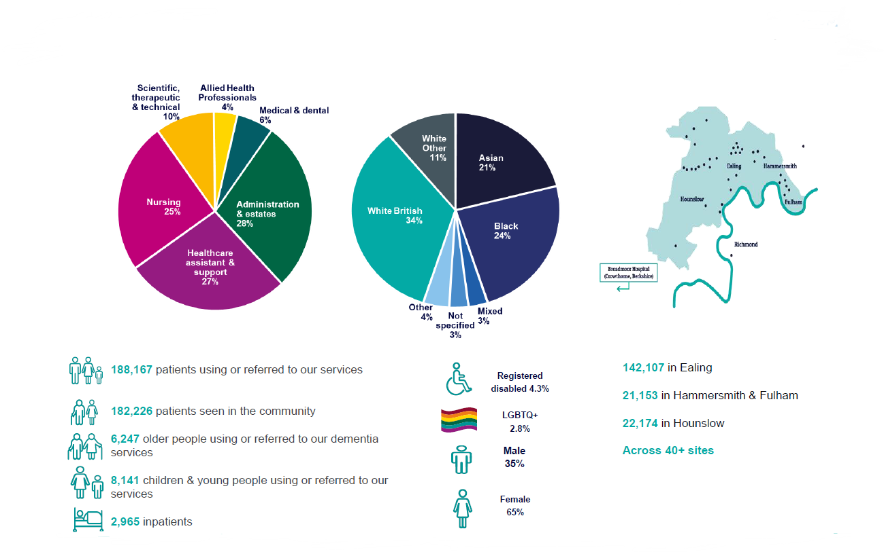

How we are organised

Each of the Talking Therapies services is organised slightly differently, but the structure below is an outline for how some of the services are structured:
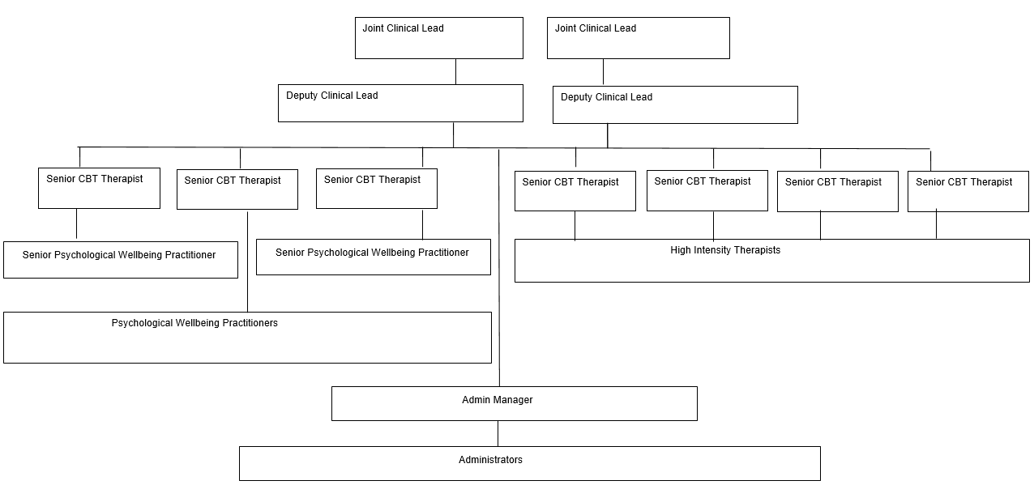

Our Trust Values

Togetherness: Ensure teamwork, mutual respect and trust sit at the heart of everything we do here. Our service users and their carers are an integral part of the team
Responsibility: Ensure when we say we are going to do something, we do it. We do not leave it to someone else to do. Our service users are responsible for engaging in their treatment.
Excellence: Ensure we strive for excellence in everything we do. ‘Good enough’ is simply not good enough. Excellent is better. The safety of our service users and our team is our number one priority.
Caring: Ensure caring means more than showing compassion to our service users and each other. It is also about having a can-do attitude, stepping up and caring to be the best we can. Because we care, we give praise when it’s due.

Job Description

Post title: | Talking Therapies Trainee Psychological Wellbeing Practitioner
Grade: | 4
Responsible to | Clinical Lead
Key Relationships
Patients and staff in the triborough Talking Therapies services, other West London services, and agencies responsible for service users’ care.

Trust Values

The post holder will

Togetherness: Ensure teamwork, mutual respect and trust sit at the heart of everything we do here. Our service users and their carers are an integral part of the team

Responsibility: Ensure when we say we’re going to do something, we do it. We don’t leave it to someone else to do. Our service users are responsible for engaging in their treatment.

Excellence: Ensure we strive for excellence in everything we do. ‘Good enough’ is simply not good enough. Excellent is better. The safety of our service users and our team is our number one priority.

Caring: Ensure caring means more than showing compassion to our service users and each other. It’s also about having a can-do attitude, stepping up and caring to be the best we can. Because we care, we give praise when it’s due.

Job Purpose

This is a training role within NHS Talking Therapies. The post-holder will work within one of the three Talking Therapies services (Hammersmith & Fulham, Ealing, Hounslow) providing high volume low intensity interventions whilst undertaking a programme of training for this role. The training post will equip the post – holder to provide a range of cognitive behavioural therapy (CBT) based self- management interventions to clients with mild to moderate anxiety and depression. The post- holder will attend all taught and self-study days required by the education provider, as specified within National Low Intensity curriculum and work in the service for the remaining days of the week using their newly developed skills.

The post holder will work with people with different cultural backgrounds and ages, using interpreters when necessary and should be committed to equal opportunities.

Key Result Areas & Performance:

Clinical

- Accept referrals via agreed protocols within the service.
- Assess and support people with a common mental health problem in the self management of their recovery.
- Undertakes patient-centered interviews which identifies areas where the person wishes to see change and or recovery and makes an accurate assessment of risk to self and others.
- Make decisions on suitability of new referrals, adhering to the department’s referral
- protocols, refers unsuitable clients on to the relevant service or back to the referral agent as necessary or steps-up the person’s treatment to high intensity psychological therapy.
- Provide a range of information and support for evidence based high-volume low intensity
- psychological treatments. This may include guided self-help computerised CBT, information about pharmacological treatments. This work may be face-to-face, telephone or via other media.
- Educate and involve family members and others in treatment as necessary.
- Adhere to an agreed activity contract relating to the overall number of client contacts offered, and clinical sessions carried out per week in order to minimise waiting times and ensure treatment delivery remains accessible and convenient.
- To work closely with colleagues in the multi-professional integrated mental health and wellbeing service on a day to day basis Attend multi-disciplinary meetings relating to referrals or clients in treatment, where appropriate.
- Complete all requirements relating to data collection within the service.
- Keep coherent records of all clinical activity in line with service protocols and use these records and clinical outcome data in clinical decision-making
- Work closely with other members of the team ensuring appropriate step-up and stepdown arrangements are in place to maintain a stepped care approach.
- Assess and integrate issues surrounding work and employment into the overall therapy process
- Operate at all times from an inclusive values base which promotes recovery and recognises and respects diversity.
- To make assessments, and deliver treatment interventions within a supervised context for individuals, carers, families and groups, and to demonstrate awareness of diversity issues
- Clients, family and carers: To communicate in a skilled and sensitive manner with clients who may have specific difficulties in understand and/or communicating and who may be distressed.
- To communicate with a wide range of health & social care staff in hospital and in community settings in a skilled and sensitive manner, concerning the assessment, formulation and treatment plans of clients under the service’s care. To provide support & guidance in the application of psychological principles and techniques, and to foster reflective practice.

TRAINING AND SUPERVISION

- Attend and fulfil all the requirements of the training element of the post including practical,
- academic and practice based assessments.
- Apply learning from the training programme in practice
- Receive supervision from educational providers in relation to course work to meet the Required standards.
- Prepare and present clinical information for all patients on their caseload to clinical case management supervisors within the service on an agreed and scheduled basis, in order to ensure safe practice and the clinical governance obligations of the worker, supervisor and service are delivered.
- Respond to and implement supervision suggestions by supervisors in clinical practice.
- Engage in and respond to personal development supervision to improve competences and clinical practice.

PROFESSIONAL

- Ensure the maintenance of standards of practice according to the employer and any regulating bodies, and keep up to date on new recommendations/guidelines set by the department of health (e.g. NHS plan, National Service Framework, National Institute for Clinical Excellence).
- Ensure that client confidentiality is protected at all times.
- Be aware of, and keep up to date with advances in the spheres of treatment for common mental health problems.
- Ensure clear objectives are identified, discussed and reviewed with senior therapists on a regular basis as part of continuing professional development.
- Participate in individual performance review and respond to agreed objectives.
- Keep up to date all records in relation to Continuous Professional Development and ensure personal development plan maintains up to date specialist knowledge of latest theoretical and service delivery models/developments.
- Attend relevant conferences / workshops in line with identified professional objectives.
- To maintain accurate records
- To plan and prioritise own workload
- To be responsible for using an email account to generate, monitor, and respond to the e-mail traffic by which the Trust conducts much of its internal communication.
- To maintain and build good working relationships with senior professional staff and managers, to foster a positive approach to the integrated mental health and wellbeing service and to enable effective negotiation.

GENERAL
- To contribute to the development of best practice within the service.
- To maintain up-to-date knowledge of legislation, national and local policies and procedures in relation to Mental Health and Primary Care Services.
- All employees have a duty and responsibility for their own health and safety and the health of safety of colleagues, patients and the general public.
- All employees have a responsibility and a legal obligation to ensure that information processed for both patients and staff is kept accurate, confidential, secure and in line with the Data Protection Act (1998) and Security and Confidentiality Policies.
- It is the responsibility of all staff that they do not abuse their official position for personal gain, to seek advantage of further private business or other interests in the course of their official duties.
- The post holder is responsible for their own professional actions, acting within Trust policies and procedures and Professional Practice Guidelines, working within clearly defined occupational procedures.
- To follow policy guidance in own role and to comment on proposed policy changes and service developments.
- This Job Description does not provide an exhaustive list of duties and may be reviewed in conjunction with the post holder in light of service development.

Person Specification
 | Criteria | Essential | Desirable | Assessment  Method
Qualifications | Evidence of ability to study successfully at undergraduate year 1 level or the equivalent (foundation degree) or successful study at level 5 | √ |  | AF
 | Minimum level 2 in English and Maths | √ |  | AF
Experience | Work or volunteer experience with people who have experienced a mental health problem | √ |  | AF/I
 | Experience of working in Primary Care Services |  | √ | I
 | Ability to manage own caseload and time |  | √ | I
 | Experience, and/or training in diversity awareness and social inequality |  | √ | I
 | Worked in a service where agreed targets in place demonstrating clinical outcomes |  | √ | I
 | Ability to evaluate and put in place the effect of training | √ |  | I
 | Computer literate | √ |  | AF/I
Skills & Competencies | Ability to integrate information; make evaluations formulations and decisions
 | Organisation and time management skills | √ |  | AF/I
 | Excellent verbal and written communication skills, including telephone skills | √ |  | AF/I
 | Able to develop good therapeutic relationships with clients | √ |  | I
 | Demonstrates an understanding of anxiety and depression and how it may present in Primary care | √ |  | I
 | Demonstrates a knowledge of the issues surrounding work and the impact it can have on mental health |  | √ | I
Knowledge | Knowledge of medication used in anxiety and depression and other common mental health problems |  | √ | I
 | Demonstrates an understanding for the need to use evidence based psychological therapies and how it relates to this post. |  | √ | I
 | Able to attend two days a week online training each fortnight and be available for in person training in London as required.  Able to complete academic components of the course.  Able to integrate training into practice | √  √  √ |  | I  I  I
 | High level of enthusiasm and motivation. | √ |  | I
Training | Ability to work within a team and foster good working relationships | √ |  | Reference
Other Requirements | Ability to use clinical supervision and personal development positively and effectively | √ |  | AF/I
 | Ability to work under pressure | √ |  | I
 | Regard for others and respect for individual rights of autonomy and confidentiality | √ |  | I
 | Ability to be self-reflective, whilst working with service users, in own personal and professional development and in supervision. | √ |  | I
 | Ability to tolerate ambiguity, and maintain own morale and motivation in challenging service delivery contexts. | √ |  | I
 | Ability to work independently within defined occupational procedures and use initiative within a service | √ |  | I/AF
 | Ability to work as a member of a clinical team. | √ |  | IAF
 | Car driver and/or ability and willingness to travel to locations throughout the organisation |  | √ | I
 | Fluent in languages other than English |  | √ | AF/I

Assessment Key
AF - Application Form
I - Interview
T - Test
P - Presentation

Main terms and conditions
Salary | Band 4
Base | 84 Uxbridge Road, Ealing Main Site or 194 Hammersmith Road or Isleworth Centre
Hours | 37.5hrs
Notice period | 1 month

General
The post holder may be required to work at any of the Trust’s sites in line with the service needs. All staff has a responsibility to participate in the Trust’s Performance Appraisal Scheme and to contribute to their own development and the development of any staff that they are responsible for appraising.

Fit and Proper Person Test
All Trust Board appointments are expected to be in accordance with the requirements of the Fit and Proper Persons Test, which covers evidencing suitability for the role, background checks and compliance with NHS Code of Conduct for Managers.

Confidentiality
The post holder must ensure that personal information for patients, members of staff and all other individuals is accurate, up-to-date, kept secure and confidential at all times in compliance with the Data Protection Act 2018, the Caldecott principles and the common law duty of confidentiality. The post holder must follow the record keeping guidelines to ensure compliance with the Freedom of Information Act 2000.

Data Protection Act
All staff have a responsibility to ensure that their activities comply with the Data Protection Act. Staff should not disclose personal data outside the organisation procedures or use personal data held on others for their own purposes .All staff has an obligation to ensure that care and/or personnel records are maintained efficiently and that confidentiality is protected.

Continuous Improvement
The Trust has adopted a strategy for Continuous Improvement and all members of staff employed by the Trust are expected to play an active role in development and improving services to the benefit of service users.

Health & safety
Staff must be aware of the responsibilities placed on them under the Health and Safety at Work Act (1974), and to ensure that agreed safety procedures are carried out to maintain a safe environment for employees, patients and visitors.

Professional registration
If you are employed in an area of work that requires membership of a professional body in order to practice, it is a condition of your employment to maintain registration of such a professional body and comply with its code of practice. You are required to advise the Trust if your professional body in any way limits or changes the terms of your registration. Failure to remain registered or to comply with the relevant code of practice may result in temporary downgrading, suspension from duty and/or disciplinary action, which may result in the termination of your employment. If you are required to have registration with a particular professional body or to have specific qualifications you must notify your manager on appointment of such fact and provide him or her with documentary evidence of them before your employment commences or, at the latest, on your first day of employment.

Risk management
All Trust employees are responsible for reporting incidents, being aware of the risk management strategy and emergency procedures and attendance at training as required. All managers have a responsibility to ensure that policies and procedures are followed, that staff receives appropriate training that a local risk register is developed and monitored on a quarterly basis and any changes reported to the Clinical Risk Management Group and Strategic Risk Management Committee.

Infection Control
All Trust staff are responsible for protecting themselves and others against infection risks and comply with infection control policies and procedures. It is our expectation that staff will voluntarily receive the annual flu jab and other vaccines relevant at the time, to protect staff and patients from infection.

Financial Regulations
All staff are responsible for the security of the property of the Trust, avoiding loss or damage of property, and being economical and efficient in the use of resources. The post holder will be required to comply with the Trust’s Standing Orders and Standing Financial Instructions and, at all times, deal honestly with the Trust and its stakeholders.

Safeguarding & Duty of Candour
All staff must be familiar with and adhere to the Trust’s safeguarding procedures and guidelines. All Trust staff have a Duty of Candour to inform their line manager as soon as practicable, when they believe or suspect that treatment or care it provided has caused death or serious injury to a patient. It is a criminal offence for any registered medical practitioner, or nurse or allied health professional or director of an authorised or registered healthcare organisation to knowingly obstruct another in the performance of these statutory duties, provide information to a patient or nearest relative with the intent to mislead them about such an incident or dishonestly make an untruthful statement to a commissioner or regulator, knowing or believing that they are likely to rely on the statement in the performance of their duties.

Standards of Business Conduct
We expect the highest standards of corporate behaviour and responsibility from our staff. All staff have a responsibility to respect and promote the Trust values and vision. When speaking as member of West London NHS Trust to the media or any other public forum, employees should ensure that they reflect the current polices or views of the organisation. Staff should ensure that they do not engage in any behaviour that can cause reputational damage to the Trust.

Valuing Diversity & Human Rights
It is the aim of the Trust to ensure that no job applicant or employee receives less favourable treatment on the grounds of sex, sexual orientation, marital/partnership status, race, religion, age, creed, colour, ethnic origin, disability and part time working status.

Agile/Flexible working
The Trust recognises that Agile Working brings a number of benefits to the organisation. Not only does it support more cost effective workplace utilisation but it also enables us to attract and retain the best talent whist increasing productivity and efficiency. The Trust is committed to supporting Agile working and empowering our staff to work in a manner that provides maximum flexibility and minimum constraints.

The Trust also continues to support staff via its flexible working arrangement options. These options enable staff to work in a way that suits their personal needs whilst also meeting the needs of the service.

No smoking policy
There is a smoke free policy in operation in the Trust. In accordance with this policy smoking is positively discouraged and is not permitted anywhere within the buildings, on the premises or grounds. Designated smoking areas or smoking rooms are not permitted. Support is provided for staff members who wish to stop smoking.

Trust Policies
All staff are required to familiarise themselves with Trust policies and comply with them at all times. Policies are reviewed regularly and may be revised from time to time.

