Job Description

JOB TITLE: Infant Feeding Deputy Ward Sister
DIVISION: Neonatal/Family Health
GRADE: Band 6
REPORTS TO: Ward Manager and Quality Care Sister
ACCOUNTABLE TO: Neonatal Lead Nurse

VALUES AND BEHAVIOURS

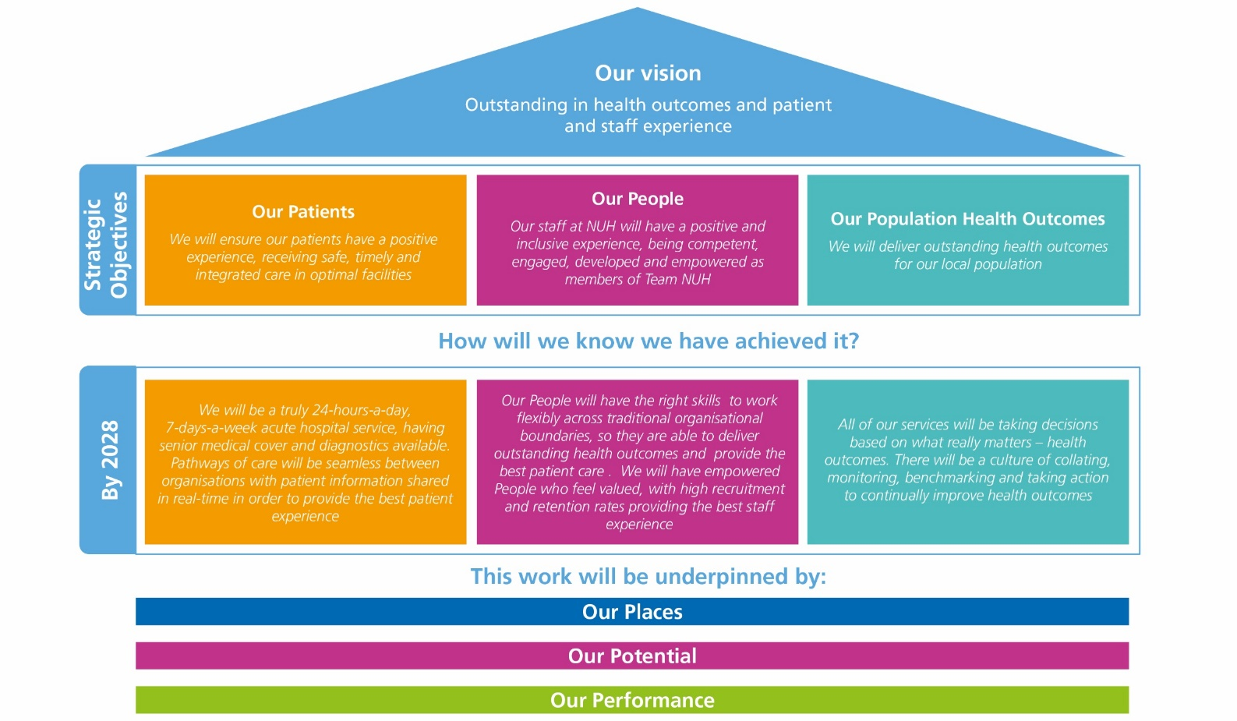

ABOUT NUH

Every day, our teams at Nottingham University Hospitals NHS Trust (NUH) make a difference. We save lives, we improve lives and we usher in new life. We are proud to play a central role in supporting the health and wellbeing of people in Nottingham, Nottinghamshire and our surrounding communities.

With more than 18,000 colleagues, we are the largest employer in Nottinghamshire and one of the biggest and busiest NHS Trusts in the country, serving more than 2.5m residents of Nottingham and Nottinghamshire and a further four million people across the East Midlands and beyond.

We provide a range of national and internationally renowned specialist services and we are at the forefront of new surgical procedures and research programmes.

We are home to the East Midlands Major Trauma Centre, the Nottingham Children's Hospital and in partnership with the University of Nottingham we host a Biomedical Research Centre carrying out vital research into hearing, digestive diseases, respiratory, musculoskeletal disease, mental health and imaging.

As a teaching hospital, we are instrumental in the education and training of doctors, nurses and other healthcare professionals. We are proud of our strong relationships with universities across the East Midlands, including the University of Nottingham, Nottingham Trent University and Loughborough University.

The last year has been challenging for our teams. Alongside our continued recovery from Covid, our maternity services are subject to an independent review and we must do more to improve our culture. We are more focused than ever on making sustained improvements across our services.

As one of the NHS Trusts identified in the New Hospital Programme, a programme of investment in NHS hospitals, we have extensive plans to improve our hospitals and the services we deliver for patients. As well as the redevelopment of the Queen’s Medical Centre and City Hospital, plans for a new 70 bed NHS rehabilitation facility set to be built on the Stanford Hall Rehabilitation Estate near Loughborough, are currently going through the approvals process.

We have recently become home to the latest series of Channel 4’s award-winning series 24 Hours in A&E, which takes a look inside one of the country’s busiest emergency department at QMC and showcases the dedication, passion and skill of our teams.

This is an exciting time to join NUH and help support our future ambitions.

JOB SUMMARY

The post holder will have responsibility for the development and implementation of infant feeding policy, governance and pro-active within the Neonatal Service to meet nation and local standards, and address health inequalities. The post holder will work as a member of the neonatal infant feeding team to participate in the planning and organisation of a broad range of activities to improve infant feeding within the neonatal service. They will support breastfeeding development within each unit and will implement NICE best practice standards and work towards the achievement of Baby Friendly Initiative Accreditation. The post holder will be highly visible within clinical areas facilitating the development of the wider clinical team, with an expectation that 80% of their time should be spent working clinically. The post holder will act as Deputy to the Ward Sister/Charge Nurse regularly taking charge of the unit and ensuring that the standards and quality of care given to babies, together with the environment in which care is delivered, are maintained at a high standard. The post holder will be expected to be an effective leader and role model and will be expected to provide regular direct clinical care and use experience to support the implementation of both clinical and non-clinical governance. He/she will be required to work flexibly as a member of the unit team and in support of the Ward Sister/Charge Nurse to ensure standards are being maintained, evaluated, and where necessary improved. The post holder is required to be registered with the Nursing and Midwifery Council.

KEY JOB RESPONSIBILITIES

Clinical
1. HWB 2 Ensure high quality, evidence-based care is offered to patients and, in collaboration with the Ward Sister/Charge Nurse, identify the common issues which affect the quality of care, devising clear action plans to address any shortcomings ensuring agreed action is undertaken.

2. Core 4 In collaboration with the Ward Sister/Charge Nurse, ensure that the patient has a satisfactory experience by evaluating patient processes and redesigning the pathway of care.

3. Core 5 Improve and maintain standards of essential (basic) nursing care by working with the Ward Sister/Charge Nurse and using tools such as clinical benchmarking.

4. Core 4 Support the Ward Sister/Charge Nurse in ensuring clinical audit takes place in line with the Trust’s requirements to improve practice.

5. HWB 6 During regular clinical sessions, act as a role model and teacher, working alongside other staff including visiting all patients in the ward in the absence of the Ward Sister.

6. Core 3 Work with the Ward Sister/Charge Nurse to identify hazards relating to clinical and non-clinical risks and undertake identified risk assessments. Ensure that junior staff also see this as important by maintaining a culture which will support the delivery of both clinical and non-clinical governance within the ward or department.

7. Core 3 Along with the Ward Sister/Charge Nurse, support the ward or department team in completing appropriate risk assessments and develop action plans accordingly in order to provide a safe environment for the delivery of high quality patient care.

8. HWB2 Ensure that all nursing documentation is regularly and appropriately reviewed and updated with changes implemented.

Neonatal Specific
1. Maintain effective communications with parents/carers, relatives and other members of the multidisciplinary team to ensure that appropriate information is shared and patient needs are met.

2. Organise and prioritise own workload to ensure that the needs of babies and their families are met.

3. Promote and demonstrate contemporary and proactive approaches to neonatal intensive care nursing practice and in collaboration with other senior nurses facilitate the advancement of this practice.

4. Act as the baby and families advocate ensuring that their best interests come first.

5. Facilitate a breast-feeding culture.

6. Facilitate partnership with parents/carers in all aspects of caring for their baby in hospital and at home.

7. Facilitate a family centred culture within the neonatal intensive care unit. 8. Work in all clinical areas of the service on a rotational basis.

Role Specific
1. Advise on the review and purchase of breastfeeding equipment and resources.

2. Consult with parents who are have breast/chest feeding issues.

3. Oversee pump rentals within the neonatal service.

4. Plan, teach and conduct in-service education for nursing staff.

5. Act as a catalyst for change, ensuring that solutions and outcomes are based upon recognised research findings, beast practice and innovation in infant feeding.

6. Organise, as part of the infant feeding team, the delivery of national and local feeding campaigns e.g. world breastfeeding week.

7. Respond to daily challenges with a positive, proactive and professional manner to encourage team working and maintain morale.

Education

Support of the Ward Sister/ Charge Nurse in:
1. G6 Undertaking a Training Needs Analysis within the defined clinical area, linked to the performance management process and collate the results on an annual basis to inform the training plan for the area.

2. Core 2 Identifying opportunities for staff to access appropriate education and training programmes, and other learning opportunities such as shadowing, mentoring and action learning, ensuring equity and fairness of access.

3. Core 2 Ensuring all staff in the defined clinical area are competent in the use of equipment and have access to appropriate training.

4. Core 2 Acquiring and maintaining an appropriate repertoire of management skills, engaging on continuing professional development appropriate to the field of practice and continue to develop competency in line with agreed personal development plans, including leadership skills and enable the empowerment of other members of ward teams.

5. Core 2 Delivering suitable induction and preceptorship programmes for staff.

6. Core 2 Encouraging a culture of learning where students receive quality clinical placements supported by mentorship, teaching and support from registered nurses.

7. Core 2 Ensuring that all staff within the ward or department undertake the required mandatory training including back care and handling, cardiopulmonary resuscitation and fire.

8. Core 2 Ensuring clinical supervision within the clinical area is actively supported and staff encouraged to avail themselves of it.

9. Core 2 Being a major contributor in maintaining an environment conducive to learning and development

Knowledge and Communication

Support of the Ward Sister/Charge Nurse in:
1. Core 5 Ensuring that best practice undertaken is shared with colleagues in the directorate, division and the Trust.

2. HWB5 Developing a culture that ensures the contribution to research and the use of evidence to support innovation and practice at ward/department level.

3. HWB 5 Helping staff to use clinical information within the ward or department to help improve the quality of patient care.

4. Core 4 Encouraging staff to be involved in service changes and developments using processes defined within the directorate/division.

5. Core 1 Participating in a communication strategy which enables effective, two-way communication between the clinical area, the directorate and the division.

6. Core 1 Being able to demonstrate clear lines of communication within a defined clinical area which result in clear responsibilities being identified within the multi-professional team.

7. Core 5 Creating a culture where staff have appropriate authority over issues that contribute to the provision of essential care and enable them to secure and achieve the highest quality standards.

8. HWB 5 Being a visible point of contact for patients, visitors, relatives and staff acting as a resource for problems and needs and able to clearly present the patient’s view to others.

9. Core 4 Participating in the development of patient care policies, procedures and guidelines.

10. G6 Assisting in the establishment, motivation and development of the clinical team with a clear focus and direction.

11. G6 Ensuring that the clinical team is kept informed of the policies, direction and strategy of the directorate and division.

12. HWB 6 Providing an authoritative and credible source of knowledge and specialist clinical advice and support to the team.

13. Core 2 Taking an active role in self-development and identifying one’s own needs, taking appropriate steps to meeting those needs.

14. Core 4 Cooperate with and participate in research in order to improve patient care.

15. Core 4 Lead and direct the implementation of relevant research-based practice.

Use of Resources
1. Core 5 Support of the Ward Sister/Charge Nurse in the management of ward or department budget, to ensure effective use of resources and a balanced budget at the end of each year.

2. Core 5 Encourage ward/department staff to be involved in the management of resources, by effective use of clinical and non-clinical supplies and understanding of financial issues.

3. Core 4 Contribute to the work of time limited committees and project groups.

4. HWB 6 Ensure that, where applicable, information is maintained and kept in an appropriate place and that accurate records are maintained and stored in accordance with Trust and national policy.

5. Core 4 Be a major instrument of change within the clinical area in response to clinical incidents and/or demands.

6. G6 Participate in acting-up rota as required, holding the directorate/floor bleep as necessary.

GENERAL DUTIES
In addition to the key job responsibilities detailed in this job description all employees at Nottingham University Hospitals NHS Trust are expected to comply with the general duties detailed below:
Infection Control
To maintain a clean, safe environment, ensuring adherence to the Trust’s standards of cleanliness, hygiene and infection control.

For senior/clinical managers the following statement must also be included
The post holder is accountable for minimising the risks of infections and for the implementation of the Code of Practice for the Prevention and Control of Healthcare Associated Infections as outlined in the Health Act 2006. This includes receiving assurance of risk and embedding evidence based practice into daily routines of all staff.

Safeguarding children, young people and vulnerable adults
Nottingham University Hospitals is committed to safeguarding and promoting the welfare of children, young people and vulnerable adults. All staff and volunteers are therefore expected to behave in such a way that supports this commitment.

Information Governance
All staff have an individual responsibility for creating accurate records of their work and for making entries into and managing all NHS records effectively in line with the Health Record Keeping Policy and other Health Records and Corporate Records Management policies and procedures in order to meet the Trust’s legal, regulatory and accountability requirements.

Health and Safety
To take reasonable care to prevent injury to themselves or others who may be affected by their acts or omissions.

To co-operate fully in discharging the Trust policies and procedures with regard to health and safety matters.

To immediately report to their manager any shortcomings in health and safety procedures and practice.

To report any accidents or dangerous incidents to their immediate manager and safety representative as early as possible and submit a completed accident/incident form.

To use protective clothing and equipment where provided.

Whilst the aim of the Trust is to promote a co-operative and constructive view of health and safety concerns in the organisation, all staff must be aware that a wilful or irresponsible disregard for safety matters may give rise to disciplinary proceedings.

Governance
To actively participate in governance activities to ensure that the highest standards of care and business conduct are achieved.

Health and Wellbeing
Employees are expected to take all reasonable steps to look after both their physical health and mental health. To support employees to achieve this NUH offers a wide range of health and wellbeing activities and interventions. The full programme can be viewed at on the staff intranet.

Line managers are expected to encourage and support staff to look after their health and wellbeing, including the release of staff to attend health and wellbeing activities and interventions.

General Policies Procedures and Practices
To comply with all Trust policies, procedures and practices and to be responsible for keeping up to date with any changes to these.

WORKING CONDITIONS
Describe the post holder’s normal working conditions (such as exposures to hazards, requirement for physical effort etc).

JOB REVISION
This job description should be regarded as a guide to the duties required and is not definitive or restrictive in any way. The duties of the post may be varied from time to time in response to changing circumstances. This job description does not form part of the contract of employment.

Service Review
A strategic review of all Trust services is taking place, as a result of which some services, or parts of some services, may transfer from one campus to the other. This will be decided in accordance with the most appropriate way to provide the best healthcare for patients in the future and all staff will be fully consulted on about the impact of any such decisions.

Job description reviewed by:
Date:

