Ffurflen Gofynion Gweithredol Iechyd Galwedigaethol
I'w gwblhau gan y Rheolwr Recriwtio
Occupational Health Functional Requirements Form
To be completed by Recruiting Manager

Cyflogwr Employer
Os yw'n wahanol i'r cyflogwr uchod, nodwch pa Adran Iechyd  Galwedigaethol sy'n gyfrifol am ddarparu Cliriad  If different to employer above, please state which Occupational Health Department is responsible for providing Clearance? |  |  | Click or tap here to enter text.
Teitl Swydd: Job Title: | Rotational Pharmacy  Technician Vaccination,  Pharmacy Stores and  Community Services | Adran/Ward Newydd:  New  Department/Ward: | Medicines Management
Band/Gradd: Band/Grade: | 5 | Sylfaen/Lleoliad Newydd:  New Base/ Location: | TBC
Dyddiad  Cychwyn Disgwyliedig  :  Expected  Start Date: | Click or tap here to enter text. | Enw Rheolwr:  Manager Name: | Nikki Mathers
Oriau:  Hours: | ☒ Llawn Amser  Full time  ☐ Rhan Amser  Part time  ☐ Arall: Nifer yr oriau  /sesiynau  Other: Number of hours/sessions | Cyfeiriad Ebost Rheolwr: Manager Email Address: | Nikki.mathers@wales.nhs.uk
 |  | Clirio E-bost i'w anfon at:  Email Clearance to be sent to: | RECRUITMENT TO AMEND  FOR ALL WALES SERVICES  ONLY
Contract: Contract: | ☒ Parhaol  Permanent  ☐ Dros Dro  Temporary  ☐ Anrhydeddus  Honorary
 |  | Cyfeirnod Swydd: Job Reference Number: | 070-PST013-0424
Beth yw gofynion penodol y rôl?  What are the specific requirements of the role? |  |  |  | Please Tick all that apply
Dim cyswllt â chleifion / mynediad i gleifion dros y ffôn/rhithwir No patient contact / access to patients via telephone/virtual |  |  |  | ☐
Bydd y rôl yn cynnwys cyswllt / mynediad at gleifion / cyswllt â hylifau'r corff / meinwe  Role will involve contact / access to patients/ contact with body fluids/tissues |  |  |  | ☒
Mae’r rôl angen cliriad ar gyfer Gweithdrefnau a allai arwain at gysylltiad (EPP)  Gweithdrefnau EPP yw’r gweithdrefnau hynny lle gall dwylo menig y gweithiwr ddod i gysylltiad ag offer miniog, blaen nodwyddau neu feinwe miniog (e.e. sbigylau o asgwrn neu ddannedd) y tu mewn i geudod corff agored, clwyf neu ofod anatomegol cyfyng lle mae’n bosibl na fydd y dwylo neu flaenau’r bysedd yn gwbl weladwy bob amser.  Role requires clearance for Exposure Prone Procedures (EPP)  ( EPP Procedures are those procedures where the worker’s gloved hands may be in contact with sharp instruments, needle tips or sharp tissue (e.g. spicules of bone or teeth) inside a patient’s open body cavity, wound or confined anatomical space where the hands or fingertips may not be completely visible at all times.) |  |  |  | ☐
V2 2/8/2023 Page 1 of 2

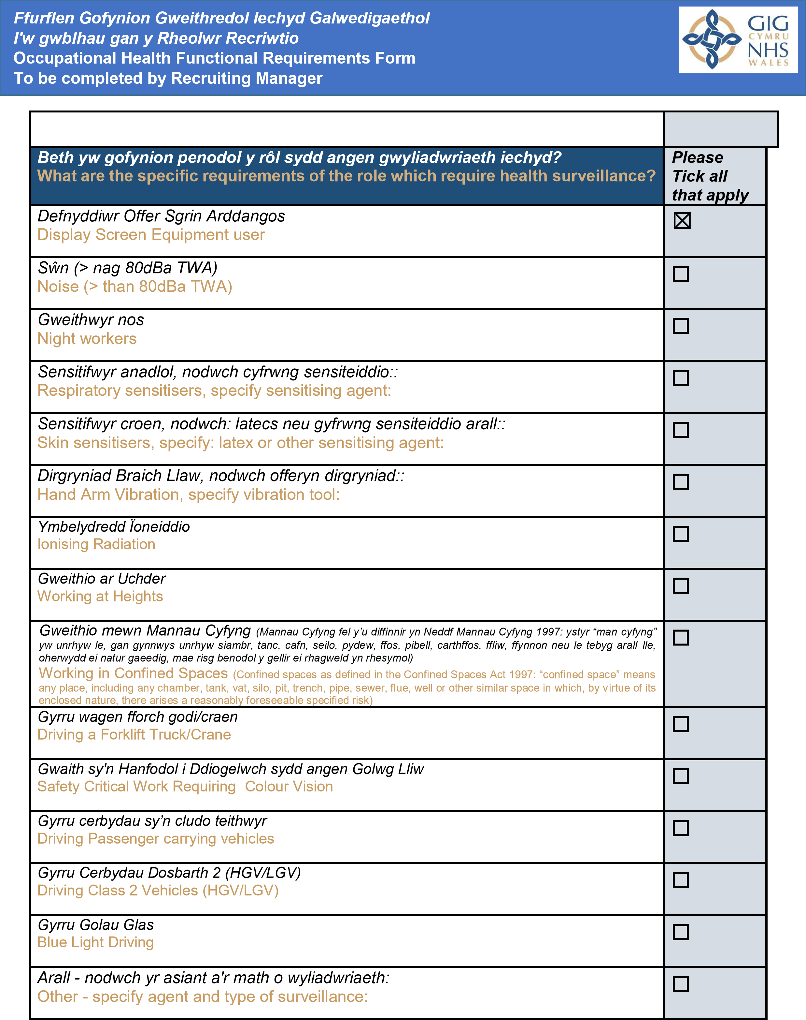
V2 2/8/2023 Page 2 of 2

